AOV pre and post slide bar

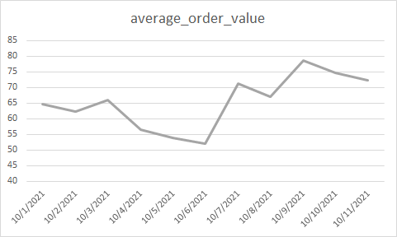

Cart to checkout conversion rate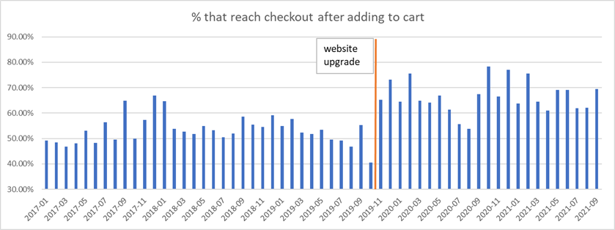

Large retail stores will not be opening on Thanksgiving Day

Walmart

Best Buy

Target

Supply chain and shipping issues:

* See more promotions of single items as opposed to site wide discounting
* Far fewer large in store promotions
* Expecting longer drawn out sales period that starts early in order to accommodate longer shipping periods
* The saving rates among all levels of income earners are 25% - 100% of their pre covid level due to high unemployment benefits and government stimulus.

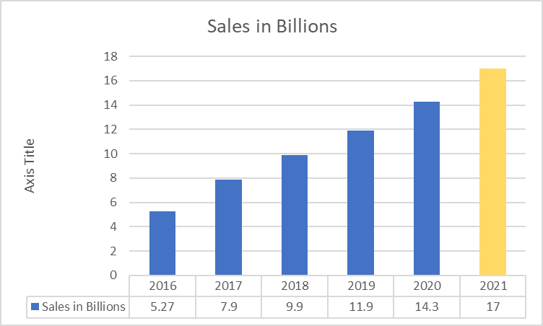

Adobe Analytics